**NANDHA COLLEGE OF TECHNOLOGY**

**ERODE- 638 052**

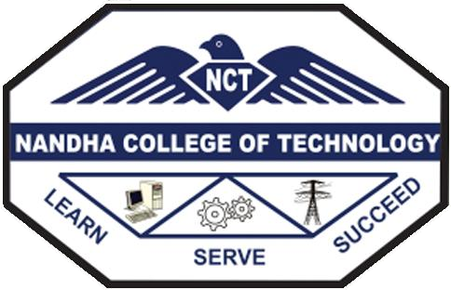

**DEPARTMENT OF INFORMATION TECHNOLOGY**

**CS3451 – INTRODUCTION TO OPERATING SYSTEMS**

(Regulations 2021)

**FOURTH SEMESTER**

(ACADEMIC YEAR 2022-23)

***ASSIGNMENT / CASE STUDY REPORT – I***

**OPENSOURCE OPERATING SYSTEM**

|  |  |
| --- | --- |
| **REGISTER NUMBER** | **732121205016** |
| **NAME OF THE STUDENT** | **C.K.DHARUN** |
| **SUBMITTED ON** |  |
| **MARKS OBTAINED** |  |
| **STAFF SIGN WITH DATE** |  |

**OPENSOURCE OPERATING SYSTEM**

**CONTENT:**

1. **INTRODUCTION**
2. **LINUX OPERATING SYSTEM**
3. **EVOLUTION OF LINUX**
4. **LINUX KERNEL**
5. **FUNDAMENTAL ARCHITECTURE OF LINUX**
6. **CONCLUSION**

**1.INTRODUCTION:**

Operating system is system software, which acts as an interface between user Applications and hardware devices such as input/output devices, memory, file system, Etc. It schedules both type of tasks, systems and users’, and provides common core Services such as a basic user interface. The two major goals of any operating system(OS) are:

* Convenience: It transforms the raw hardware into a machine that is more Accessible to users.
* Efficiency: It efficiently manages the resources of the overall computer system. Operating system consists of the following components for achieving the goals:
* Kernel: The main task of the kernel is to optimize the usage of the hardware ,Running the required programs, satisfying the user’s requirements.
* Application Programming Interface (API): A collection of rules, Which describes how services have to be required from the kernel, and How we receive the answer from it.
* Shell: Its’ task is the interpretation of commands. The shell can be command Line (CLI – Command Line Interface, such as DOS), or graphic – GUI –Interface (e.g.: Windows)
* 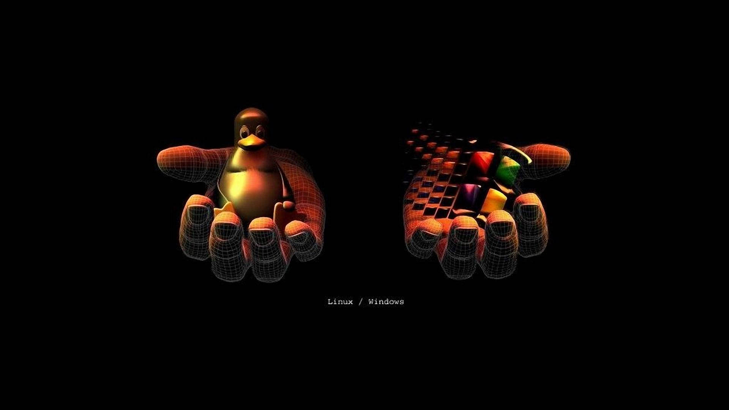Services and Utilities: These supplementary programs enhance the user’s Experience (e.g.: word processors, translator programs) and are not inseparable parts of the system.

**2.LINUX OPERATING SYSTEM:**

Linux is one of the popular variants’ of UNIX operating System. It is an open source OS as its source code is freely available. Linux was designed considering UNIX compatibility. Its functionality is quite similar to that of UNIX. Linux is provided with GUI, so instead of typing commands to perform user tasks, one can log in graphically to fulfill their requirements. Linux also provides the facility to handle core system requirements through command line. Linux developers concentrated on networking and services in the beginning, and office applications have been the last barrier to be taken down. Apart from desktop OS, Linux is an acceptable choice as a workstation OS, providing an easy user interface and MS compatible office applications like word processors, spreadsheets, presentations and the like. Because of this, Linux has joined the desktop market.

On the server side, Linux is known as a stable and reliable platform, providing database and trading services for companies like Amazon, US Post Office, German Army and many others. Linux is used in firewall, proxy and web server. One can find a Linux box within reach of every UNIX system administrator who appreciates a comfortable management station. Clusters of Linux machines are used in the creation of movies such as “Titanic”, “Shrek” and others. Day-to-day, thousands of heavy-duty jobs are performed by Linux across the world. It is also noteworthy that modern Linux not only runs on workstations, mid and high-end servers, but also on “gadgets” like PDA’s, mobiles, embedded applications and even on experimental wristwatches. This makes Linux the only operating system all across covering a wide range of hardware.

Linux is used in a number of consumer electronic devices worldwide. Some of the popular Linux based electronic devices are Dell Inspiron Mini (9 and 12), Garmin Nu vi (860, 880, and 5000), Google Android Dev Phone 1, HP Mini 1000, Lenovo IdeaPad S9, Motorola Moto EM35 Phone, One Laptop Per Child XO2, Sony Bra via Television, Sony Reader, TiVo Digital Video Recorder, Volvo In-Car Navigation System, Yamaha Motif Keyboard etc.. From smartphones to robots, cars, supercomputers, home appliances, personal computers to Enterprise Servers, the Linux operating system is everywhere.

**3.EVOLUTION OF LINUX:**

In the beginning of the 90s home PCs were finally powerful enough to run UNIX. Linus Torvalds, a Computer Science student at the University of Helsinki, thought it would be a good idea to have some sort of freely available academic version of UNIX, and promptly started to code. He started to put fourth questions, looking for answers and solutions that would help him get UNIX on his PC. From the start, it was Linus’s goal to have a free system that was completely compliant with the original UNIX. In those days plug-and-play wasn’t invented yet, but number of people was interested in having a UNIX system of their own. This was the only small obstacle. New drivers became available for all kinds of new hardware at a continuous rising speed. As soon as a new piece of hardware became available, someone bought it and submitted it to the Linux test, as the system was gradually being called releasing more free code for an even wider range of hardware. Around 95% of the Linux was written in C programming language and around 2.8% in Assembly language.

Two years after Linus announcement of the project, there were 12000 Linux users. The project, popular with hobbyists, grew steadily, all the while staying within the bounds of the POSIX (popular UNIX version) standard. All the features of UNIX were added over the next couple of years, resulting in the mature operating system Linux has become today. Linux isa full UNIX clone, fit for use on workstations as well as on middle-range and high-end servers. There is a wide range of variations and versions those were encountered in the development of Linux Operating System. The following table provides the details of the various versions developed and events happened related to Linux.

|  |  |  |  |
| --- | --- | --- | --- |
| **S. No.** | **Year** | **Event/Release** | **Version** |
| 1 | 1991 | Uni X (HP-UX) | 8.0 |
| 2 | 1992 | Hewlett Packard | 9.0 |
| 3 | 1993 | NetBSD and FreeBSD | 0.8, 1.0 |
| 4 | 1994 | Red Hat Linux, Caldera, Ransom Love and NetBSD1.0 | **-** |

|  |  |  |  |
| --- | --- | --- | --- |
| 5 | 1995 | FreeBSD and HP UX | 2.0, 10.0 |
| 6 | 1996 | K Desktop Environment | — |
| 7 | 1997 | HP-UX | 11.0 |
| 8 | 1998 | IRIX Sun Solaris OS Free BSD | 6.573.0 |
| 9 | 2000 | Caldera Systems with SCO server division announced |  |
| 10 | 2001 | Linux Microsoft filed a trademark suit against Lindows.com | 2.4 |
| 11 | 2004 | Windows name was changed to inspire First release of Ubuntu | — |
| 12 | 2005 | Open SUSE Project | — |
| 13 | 2006 | Red Hat | — |
| 14 | 2007 | Dell started distributing laptops with Ubuntu pre-installed |  |
| 16 | 2011 | Linux kernel | 3.0 |
| 17 | 2013 | Googles Linux based Android | — |

Linux has several distributions. Some popular and dominant LINUX distributions for Desktops include:

* Linux Mint
* Ubuntu
* OpenSUSE
* Mageia
* Manjaro
* Fedora
* Arch Linux
* Debian
* Kali Linux

**4.LINUX KERNEL:**

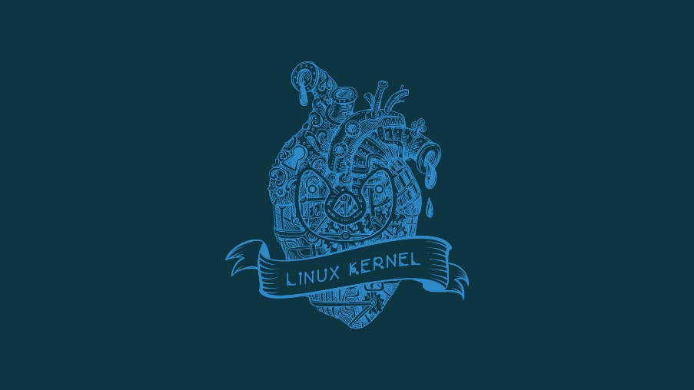Kernel is a small and special code which is the core component of Linux OS and directly interacts with hardware. It is the intermediate level between software and hardware which provides low level service to user mode’s components. It is developed in C language. Moreover, it has different blocks which manage various operations. Kernel runs a number of processes concurrently and manages various resources. It is viewed as a resource manager when several programs run concurrently on a system. In this case, the kernel is an instance that shares available resources like CPU time, disk space, network connections etc.

The Linux kernel is the main component of a Linux OS. This is the core interface between a computer’s hardware and its processes. It communicates between the two, managing resources efficiently as possible. The kernel is so named because—like a seed inside a hard shell—it exists within the OS and controls all major functions of the hardware, whether it’s a phone, laptop, server, or any other kind of computer. To put the kernel in context, one can think of a Linux system having four layers

* **The Hardware:** The physical machine—the bottom or base of the system, made up of memory (RAM), processor or central processing unit (CPU), as well as input/output (I/O) devices such as storage, networking, and graphics. CPU performs computations and reads from, and writes to the memory.
* **The Linux kernel:** The core of the OS. It’s software residing in memory that tells the CPU what to do.
* **Shell:** The shell layer is in between application layer and the kernel. Shell will take the input from the user applications and sends it to the kernel in form of instructions. It also takes output from the kernel and forwards it as a result to the user application.
* Applications / User processes: These are the running programs that the kernel manages. User processes are what collectively make up user space. User processes are also known as just processes. The kernel also allows these processes and servers to communicate with each other (known as inter- process communication, or IPC)

Code executed by the system runs on CPUs in one or two modes: kernel mode or user mode. Code running in the kernel mode has unrestricted access to the hardware, while user mode restricts access to the CPU and memory to the System Call Interface. A similar separation exists for memory (kernel space and user space).

**5.FUNDAMENTAL ARCHITECTUREOF LINUX :**

The following is the fundamental architecture of Linux:

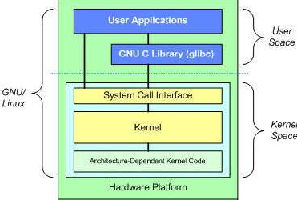

Architecture of kernel is divided into main two parts:

**1. User Space**

**2. Kernel Space**

**1.User Space:**

All user programs and applications are executed in user space. User Space cannot directly access the memory and hardware. It accesses the hardware through kernel space. Processes or programs which are running in user space only access some part of memory by system call. Due to full protection, crashes in user mode are recoverable.

GNU C library provides the mechanism switching user space application to kernel space.

**2. Kernel Space:**

All kernel programs are executed in kernel space. Kernel space accesses full part of memory and directly interacts with hardware like RAM, Hard disk etc. It is divided in different blocks and modules which manage all operations (like file management, memory management, process management etc.) in kernel space and applications running in user space. Kernel space consists of system call interface, Kernel (core component of Linux) and device module.

System call interface is the intermediate layer between user space and kernel space. Each application, running in user space, can interface with kernel through system call. For example system call function on file operation are open( ), write( ), read( ) etc.

Kernel is independent from hardware. It is common for all Hardware processors which are supported by Linux. You can run kernel on any processor like Intel, ARM, etc. It acts as a resource manager in Kernel space and performs process management, file management, memory management, Interrupt handler, scheduling of process, etc. It is a powerful structure which handles all kinds of operations

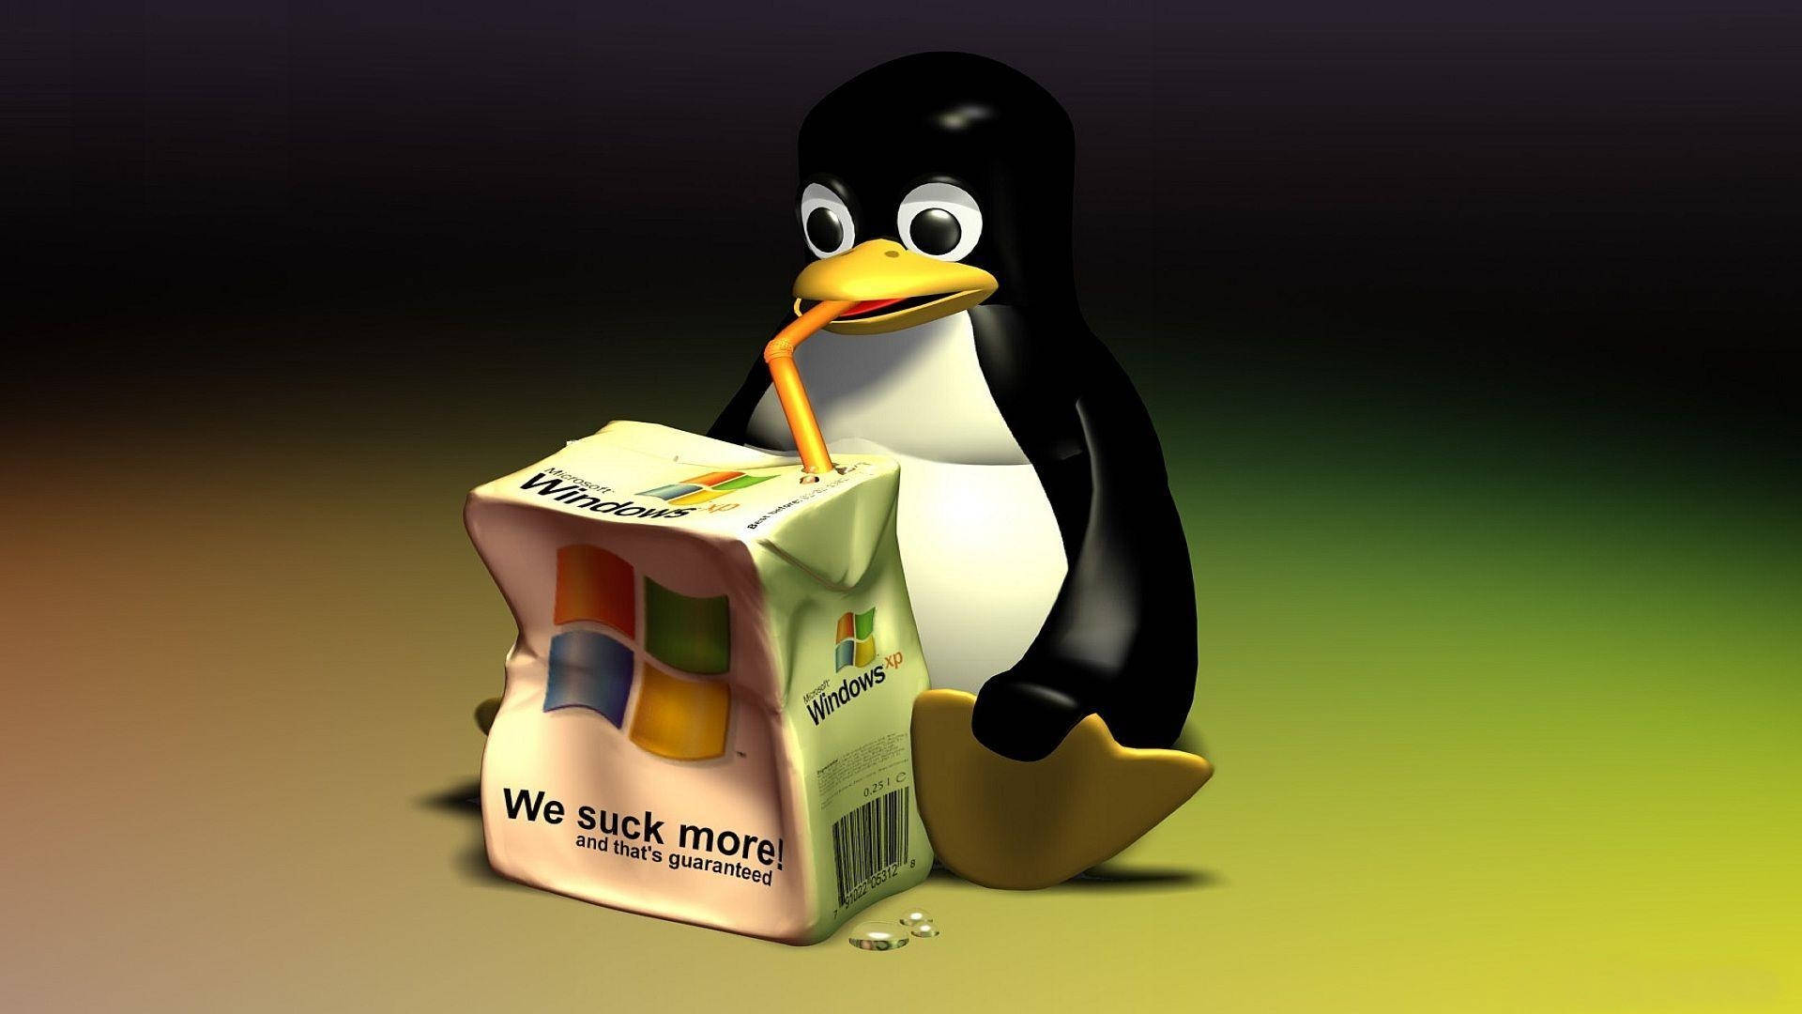

**6.CONCLUSION:**

open source operating systems have become increasingly popular in recent years due to their many benefits, such as cost-effectiveness, flexibility, and security. By using open source operating systems, organizations can avoid licensing fees and have access to a community of developers who constantly improve and update the software. Additionally, open source operating systems are highly customizable and can be tailored to meet specific business needs. However, there may be some challenges associated with using open source operating systems, such as a potentially steep learning curve for less tech-savvy users and potential compatibility issues with certain hardware or software. Overall, the benefits of open source operating systems outweigh the potential drawbacks, and organizations that adopt these systems can enjoy the advantages of cost savings, flexibility, and security.

